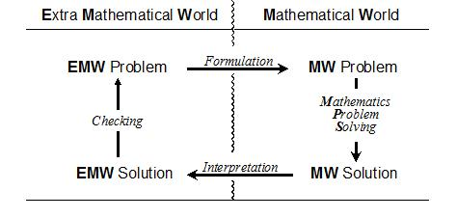
Figure 1. A model of the modeling cycle (Verschaffel, 2002)

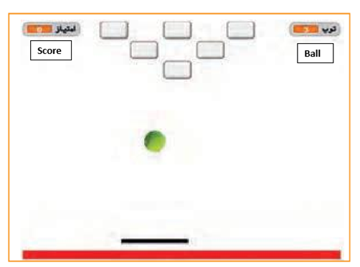
Figure 2. “balls and rocket” game page 48 of grade nine “work and technology” textbook

