DEVELOPMENT OF OPEN-ENDED QUESTIONS FOR SURFACE AREA AND VOLUME OF BEAM
Henry Kurniawan¹, Ratu Ilma Indra Putri², Yusuf Hartono²
¹Universitas Sriwijaya, Jl. Srijaya Negara Km. 32, Bukit Lama, Ilir Barat I, Kota Palembang, Sumatera Selatan 30128
Email: henrykurniawa46@gmail.com
² Universitas Sriwijaya, Jl. Srijaya Negara Km. 32, Bukit Lama, Ilir Barat I, Kota Palembang, Sumatera Selatan 30128
Email: ratu.ilma@yahoo.com
Abstract
The purpose of this research was to show open-ended questions about surface area and beam volume which valid and practice, have potential effect. This research is research development which consists of two main phases: preliminary phase (preparation phase and problem design) and formative evaluation phase (evaluation and revision phases). The objective of the study is the students of VIII.2 class of Junior High School 55 Palembang. The result of the study got 9 questions open-ended of surface area and beam volume materials which valid and practical. In addition, there was the potential effect of students' mathematical ability on the open-ended questions that have been given. The result of open-ended problem in the concept potential effect was 77,53%, reasoning ability was 59,79%, the communication ability was 57,02%, and problem solving ability was 67,01 %.
Keywords: Development Research, Open-Ended Questions development, Surface and Volume of Beam.
Abstrak
Penelitian ini bertujuan untuk menghasilkan soal open-ended pada materi luas permuakaan volume balok yang valid dan praktis dan memiliki efek potensial. Penelitian ini merupakan penelitian pengembangan jenis design research tipe development study (development research) yang terdiri dari dua tahapan utama yaitu tahap preliminary (tahap persiapan dan pendesainan soal) dan tahap formative evaluation (tahap evaluasi dan revisi). Subjek penelitian ini adalah siswa kelas VIII.2 SMP Negeri 55 Palembang. Dalam penelitian ini menghasilkan 9 soal open-ended materi luas permukaan dan volume balok yang valid dan praktis. Selain itu, didapatkan efek potensial kemampuan matematis siswa yang muncul terhadap soal open-ended yang telah diberikan. Dalam menyelesaikan soal-soal open-ended efek potensial terhadap kemampuan pemahaman konsep yang muncul sebesar 77,53%, kemampuan penalaran sebesar 59,79%, kemampuan komunikasi yang muncul sebesar 57,02%, dan kemampuan pemecahaman masalah yang muncul sebesar 67,01%.
Kata Kunci: Penelitian Pengembangan, Pengembangan Soal Open-Ended, Luas Permukaan dan Volume Balok.
How to Cite: Kurniawan, H., Putri, R.I.I., Hartono, Y. (2016). Development of Open-Ended Questions for Surface and Volume of Cubic. Journal on Mathematics Education, x (x),xx-xx.

Purwantiningsi (2013) states that students need to understand the concept of surface area and beam volume. However, in reality, Nurlatifah (2013) revealed that students cannot understand the interrelationship between the concept of surface area and the volume of beam that are stock in solving daily problems. So in this case, the matter of surface area and the volume of the beam becomes a very important material to be used to solve daily problems associated with the beam.
Based on NCTM (2000) there are 5 process standards namely problem solving, reasoning and verification, communication, connection, and representation. This is in line with the objectives of the mathematics subjects in Permendiknas No. 22, 2006 (Depdiknas, 2006) that students have the ability to: understand mathematical concepts, use reasoning, solve problems, communicate ideas, and have an attitude of appreciating the usefulness of mathematics. However, the facts show that one of the failures of the current math teacher is because it is unable to make students think critically and creatively and independently in learning, so that most students find it very difficult to quickly absorb and understand the math lesson (Tandilling, 2012). The results of TIMMS and PISA studies also show that the ability of junior high school students especially in the field of mathematics is still below international standards. The latest results of TIMSS 2011 put Indonesia in the 38th rank of 42 countries (HSRC & IEA, 2012) and more worrying about the latest PISA 2012 results that put Indonesia on 64th out of 65 countries (OECD, 2013). Meanwhile, according to Emilya (2010) an open mathematical problems (open problems) alone is rarely touched upon presentation of the problems in the learning process of mathematics in schools. As a result when there is a problem or problem it is considered "wrong question" or an incomplete matter. Yusuf (2009) also states that the textbooks students use when studied honestly, all the problems that it contains mostly include tasks that must find a correct answer (convergent). The ability to think diverges, ie exploring possible answers to a problem is rarely measured. Thus the child's intellectual ability to thrive is completely ignored. Agree with it, Mustikasari (2010) also stated that based on observation of math textbooks used in secondary schools, the problems in the book is very rarely given about the form of open-ended. Because of the need for standard questions, of which can train high-level understanding, students can learn to think critically and creatively (Tandilling, 2012).
To solve the above problem, Mahmudi (2008) suggests that the use of open questions needs to be cultivated in learning because open questions have rich potential to improve the quality of learning. In addition, by providing an open problem (open-ended problems) is also expected to bring students to address issues in many ways, thus inviting intellectual potential and experience of the students in the process of discovering something new (Shimada, 1997). Emilya (2010) also added that the open-ended questions require students' creativity in thinking required to answer for more than just considering the standard procedure in resolving a problem. So based on the above descriptions, the researchers developed the open-ended questions on the material surface area and volume of the beam with the formulation of the problem as follows:
- How characteristic of open-ended questions on the material surface area and volume of the beam in class VIII valid and practical?
- How about the potential effects of open-ended on the material surface area and volume of the beam in class VIII Junior High School 55 Palembang?
Mathematics Learning
Permendiknas No. 22 year 2006 (Depdiknas, 2006) states that the subjects of mathematics aim to have students such as: understanding mathematical concepts, using reasoning, solving problems, communicating ideas, and having an appreciative attitude to the usefulness of mathematics. To make students master the ability, the teacher has an important role so that the learning that occurs in the classroom can take place optimally and qualified in class. The quality of learning can be seen from the approach or instrument used in teaching and learning process, because the success or failure of the goals to be achieved is influenced by the effectiveness or not the teaching and learning process experienced.
Student Math Ability
Depdiknas explained there are aspects of mathematics competence (skills) in Mathematics subjects consist of abilities in: (1) understanding of concepts; (2) understanding procedures; (3) reasoning; (4) communication; (5) problem solving and (6) appreciation of the use of mathematics. (DEPDIKNAS, 2006). This is in line with Permendiknas No. 22 year 2006 (DEPDIKNAS, 2006) states that the subjects of mathematics aim to have students such as: understanding mathematical concepts, using reasoning, solving problems, communicating ideas, and having an appreciative attitude to the usefulness of mathematics.
Open Ended Questions in Math
Shimada (1997) said the open-ended approach is an approach to learning that starts from the introduction or exposes students to the open-ended problems. While the definition of an open-ended question is formulated problems have many correct answers. Problem is open (open-ended problem) given aims to help develop creative activities and mindset of the students through problem solving mathematical simultaneously (Nohda, 2011). According to Takahashi (2006) the benefits of using open-ended questions in mathematics learning are students becoming more active in expressing their ideas, having more opportunities to comprehensively use knowledge and skills, and have rich experience in the process of finding and accepting approval from other students Against their ideas.
From the opinions can be concluded that open-ended questions are questions that have many answers correct and also have lots of ways to solve them. So that students are required to be able to think more intelligently and also required in bringing the creativity in answering questions.
Permendiknas (2006) states that the study of mathematics by simply giving problems Convergen cause learning process actively and creatively abandoned, but in one of the pillars of learning mentioned that learning is to build and self-discovery, implemented through a learning process that is active, creative, And fun. According to Mahmudi (2008) to maximize the learning of mathematics, the use of open questions needs to be cultivated in learning because open matter has rich potential to improve the quality of learning.
Some of the criteria according Suherman (2003) open ended question, namely: 1) Problem to be rich with valuable mathematical concepts; 2) the level of questions or math levels of the questions should be suitable for students; And 3) Problems should invite the development of further mathematical concepts.

METHOD
This study is the type of research design development study which was developed with a repeating cycle using formative evaluation (Tessmer, 1993). The subject of this research is the students of class VIII junior high school 55 Palembang. This research procedure consists of two main stages, namely preliminary study and formative evaluation.Preliminary study stage consists of a stage of analysis (analysis of students, curriculum, and teaching materials), designing stage (prototyping) while formative evaluationstage consists of self-evaluation, prototyping (expert reviews, one-to-one or small group), and field test. Here is a picture of the design flow of formative evaluation:
Small
Group
Revise
Field Test
Revise
Self Evaluation
Expert Review
Revise
One to one

Figure 1. Design groove Formative evaluation (Tessmer, 1993)
Data collection techniques in this study using a walkthrough, document and test. In the walkthrough data analysis, researchers analyzed the results of the validation by experts, and used to revise the questions that have been made by researchers. Documents used to obtain data effectiveness are produced by analyzing the results of the questions given to students.Analysis of the test data open-ended questions were used to determine the effects of open-ended questions were given to the students' learning outcomes.
RESULTS
Preliminary
At this stage, based on the results of interviews with grade VIII mathematics teachers obtained many students who will be subjected to research there are 38 students with an estimated 30% of high-ability students, 40% middle-ability and 30% have low ability. While the curriculum used is the education unit level curriculum (KTSP) where the selected material is a beam with basic competence, among others, calculate the surface area and volume of cubes, beams, prisms and pyramids. However, researchers only focus on the surface area and volume of the beam only. In addition, the eighth grade teachers also stated that in the learning of students are rarely given the open ended questions.
Furthermore, at the stage of designing the researchers designed the initial prototype open-ended questions as much as 10 grains of essays with the type of questions that have a way with a lot of answers. In addition, researchers also prepared grille open ended question.
Formative Evaluation
Self-evaluation
Problem open ended which has been designed to be reviewed by the researchers subsequently revised and produce prototype 1.
Prototyping
Expert Review and one-to-one
The second stage was conducted simultaneously, aiming to see the validity of the questions that have been developed. Atthe stage of expert reviews, prototype 1 validated to one expert on open ended, Dr. Rahmah Johar, M.Pd, Lecturer of Mathematics at Syiah Kuala University, Banda Aceh. While on stage one to one, prototype 1 tested to three students with different abilities.
Based on the results obtained advice from expert review were: 1) Problem that requires a lot of possibilities need to be made rubric scoring; 2) There should be enough 8 or 6 pieces of matter; 3) the matter of a lot of wasted water and the building of blocks from the cube is less challenging to the students; And 4) some questions are not non-routine. While on stage one to one obtained by the students' comments stating that the open-ended question is interesting though when first saw this issue was a bit confused.
Furthermore, researchers conducted an analysis about the item to test the validity of using the formula Pearson Product Moment correlation and reliability problems quantitatively using Cronbach Alpha formula with the help of Microsoft Excel software. The following are Table 1 data and the results of its calculations.
Table 1. Data on the calculation of the validity of the item
Item Problem | r _{count} | Information  (valid if r _{count>} r _{table)}
1 | 0.781 | Valid
2 | 0.053 | Invalid
3 | 0.657 | Valid
4 | 0.497 | Valid
5 | 0.308 | Invalid
6 | 0.438 | Valid
7 | 0.596 | Valid
8 | 0.436 | Valid
9 | 0.445 | Valid
10 | 0.590 | Valid
While the expert review stage and one to one, after being validated and tested prototype 1 hereinafter researchers revised based on suggestions and comments given validator. Figure 2. (a) and (b) below is one of the changes that occur in the problem.
Problem 10

- Before the revision

- After revision
Figure 2. Before and after the revision of 10
Problem in the picture above is the changes that occur in a matter of 10 where the advice of the expert stated that the matter of the cubes into blocks composing considered less challenging and eventually turn it into a question researchers are asking the students to design the size of the aquarium that can hold water to a certain size.
Based on the results of phase one to one and expert review, prototype 2 is obtained in the form of open-ended questions, consisting of 9 questions with material volume and surface area of cubes and blocks.
Small group
At this stage, the researchers fed the questions open-ended prototype 2 which consists of nine questions to the six students of Junior High School 1 Belitang III with 2 high ability students, 2 students the ability moderate, and 2 low ability students. Figure 3 below is an example of the results of the students' answers on the stage of a small group.

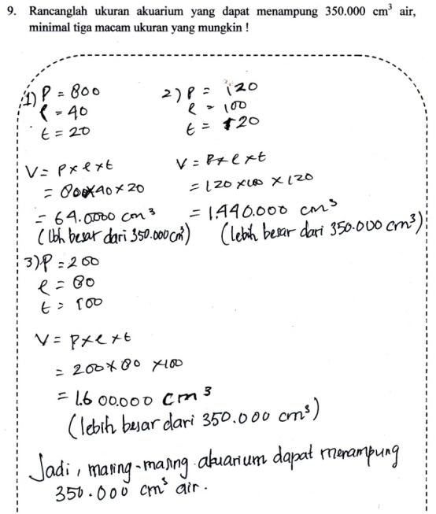
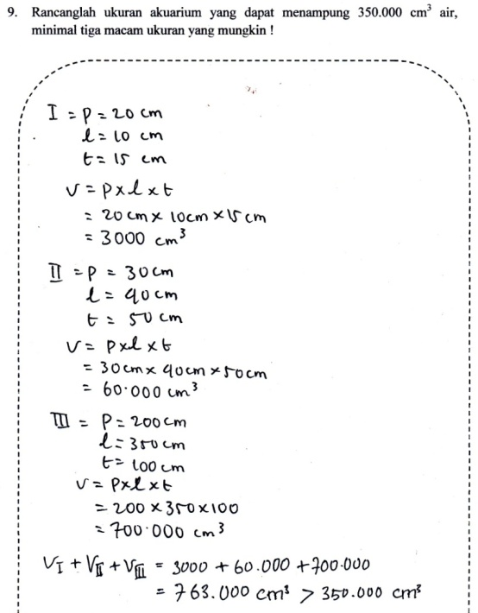

Figure 3. Answer students small group
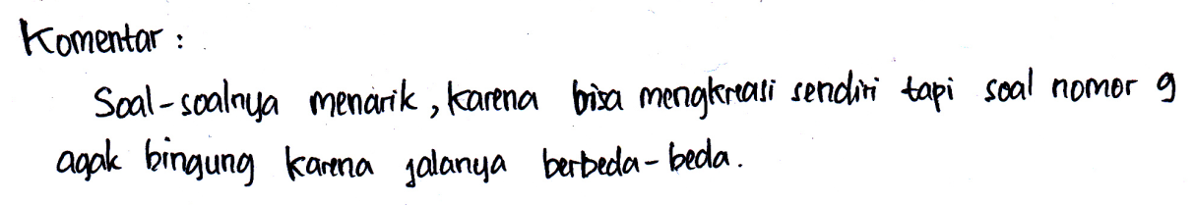
After they finish answering the question, the researcher asks the six students to comment on the questions they have been doing. Following Figure 4 of the student comments.

Figure 4. Small group student comments
After the students answer the questions and give their comments, then the researchers analyze and revise the problem that is considered problematic. Figure 5 below is an example that is considered problematic for students to understand.
Problem 9

- Before the revision

- After revision
Figure 5. Before and after revision about problem 9
Based on Figure 5 on problem number 9 there is a change that is the researcher clarify the purpose of the matter.
Field test
Phase field test was conducted at Junior High School 55 Palembang VIII.2 class with a number of research subjects are 38 students. This stage was held on December 16, 2016 for three lessons (120 minutes). Below is Table 1 on the percentage of mathematical ability of each question.
Table 2. Percentage of Students' Mathematics Ability on each Problem
Problem Number | Mathematical Capabilities (%) |  |  |  |  | Average (%)
 | Understanding Concepts | Reasoning | Solving  Problem | Communication | Open Ended
1 | 86.84 | 71.05 | 80.7 | 71.05 | 84.21 | 78,42
2 | 82.89 | 60.53 | 78.94 | 52.63 | 84.21 | 78.65
3 | 89.48 | 43.43 | 56.58 | 44,74 | 68.42 | 64,74
4 | 52.64 | 35.97 | 36.84 | 36.84 | 34.21 | 57.08
5 | 72.37 | 61.85 | 67.11 | 44,74 | 81.58 | 78.29
6 | 36.84 | 52.64 | 31.58 | 44,74 | 26.32 | 50.13
7 | 82.9 | 60.53 | 54.39 | 73.68 | 65.79 | 81.46
8 | 86.84 | 78.95 | 77.63 | 78.95 | 81.58 | 83.68
9 | 53.51 | 53.95 | 59.21 | 28.95 | 63,16 | 68.16
Average | 71.59 | 57.65 | 60.33 | 52.92 | 65.49 | 61.59
Table 3. Distribution of students' mathematical abilities
Student scores | Frequency | Percentage | Category
86 - 100 | 20 | 52.63 | Very good
71 - 85 | 4 | 10.53 | Good
56 - 70 | 0 | 0.00 | Enough
41 - 55 | 6 | 15.79 | Less
0 – 40 | 8 | 21.05 | Very less
amount | 38 | 100
Average | 68.16 |  | Enough
DISCUSSION
The problems of this study is how the characteristics about the open-ended on the material surface area and volume of the beam in class VIII valid and practical, as well as how potential effect about the open-ended subject matter surface area and volume of the beam in class VIII Junior High School 55 Palembang. Therefore, to produce open-ended questions that are valid, practical, and have a potential effect, researchers designed an open-ended question using the development process consists of two stages: stage preliminary and prototyping phase using formative evaluation workflow.
Characteristics of Open-ended Questions to Content Surface and Volume Cubics Valid and Practical
Characteristics are characteristic in accordance with certain types (Kemdikbud, 2008). Characteristics of open-ended questions on the subject of surface area and volume of the beam is obtained from the development process that uses a groove formative evaluation. Characteristics of the validity of open-ended questions on the subject of surface area and volume of the beam obtained from stage expert review, one to one evaluation, and also the validity of the test phase items. While the characteristics of practicality of open-endedquestions on the subject of surface area and volume of the beam obtained from the stage of a small group.
Characteristics of Validity
Characteristics of validity of open-ended questions on the material surface area and volume of this beam in terms of content, construct, and language. In terms of content can be seen from 1) conformity with the Competency Standards (SK) on the curriculum (SBC); 2) conformity with Basic Competence (KD) on curriculum (KTSP); 3) compliance with indicators of achievement of competence; 4) compatibility with the level of competence of students of class VIII.
Characteristics of open-ended question the validity of the material on the beam surface area and volume in terms of the constructs are: 1) the formulation of the sentence in question in accordance with the characteristics of the instrument of open-ended questions; 2) the question of demanding many answers with a single way of settlement; 3) there is a clear direction in working on the problem.
Characteristics of the validity of open-ended questions on the material surface area and volume of the beam in terms of language, namely: 1) the phrase used to use language properly and correctly in accordance with the EYD; 2) the sentence is easy to understand; 3) the formulation of a sentence does not give rise to multiple interpretations; 4) the formulation of the matter does not contain words that can offend a person.
Prototype declared invalid qualitatively based on the results and comments of students at the stage of one to one and a comment validator at the stage of expert review, and also based on the evaluation of the prototype given validator. Validator states prototype given researchers already well on the content, construct, and language. Based on comments from students and experts, researchers fix this prototype so it can be expressed qualitatively valid. While the prototype declared invalid quantitatively based on the trial results to the students, then comparing r and r _{count} _{table.} If r _{count>} r _{table,} we conclude that it is categorized as valid. Djaali and Muljono (2008) who said that if the correlation coefficient between the resultant instruments score developed with the standard instrument result score is greater than the r-table, then the developed instrument can be valid based on the selected external criterion.
Characteristics of Practicality
Characteristics of practicality about the open-ended on the material surface area and volume of the beam seen from the stage of a small group, the researchers tested the prototype on a small group of students consisting of six students capable high-level mathematics, medium and low based on information from math teachers.
At this stage the students can understand the given problem through open-ended questions on the subject matter of this beam surface and volume, or little difficulty in solving the problem by appropriate with a view matter. So on the basis of this matter, these questions can be stated practically.
Potential Effects of Open-ended Math Problem
Based on the results and analysis of the field test phase of about 1 to about 9 gained as much as 71.59% of students led to the ability of understanding the concept, 57.66% raises reasoning skills, 60.33% raises problem solving skills, and the ability to bring up 52.93% Communications. Overall the average percentage of students who gave rise to mathematical ability is as much as 60.63%. From the above analysis it can be seen that most of the students can come up with their mathematical ability during solving the given problem.
From the results of interviews with some students about the problem number 1 to number 9, can be seen the cause of students did not come up with mathematical skills.Among them are students "forgot" and "not used" to write back the information in the matter, there are also students who think that writing the information is not necessary. Even the matter "not enough time" becomes the reason for students not to write a conclusion on the answer. Besides there are also students who are not careful in understanding the problems. Some do not even understand the problems given.
From problem number 1 to number 9 there are 71.59% of students that raises the ability to comprehend the concept. There are some students who do not generate the ability to understand the concept in answering the problem with the reason "forgot" and "not used" write back the information on the problem.
Next is the reasoning ability. There are 57.66% of students who raise their reasoning ability, meaning there are still many students who do not raise their reasoning abilities.Though mathematics is learned by reason, and reason itself can be trained by using mathematics (Depdiknas, 2006). From the results of interviews with some students, it can be seen that the reason the students did not come up with the reasoning ability is the students are not careful in understanding the problem, and the researchers also considered that students are still familiar with the problems that use the standard context, so when given the problem with the context Others, students are still fixated by the method of completion in the context of the standard, so the problems that require mathematical manipulation in the answer is not done by students. In addition, the students also reasoned "forgot", "unaccustomed", and also "did not have enough time" to write conclusions on the answers. Hirschfeld and Cotton (2008) states that if they invite students to think and reason about mathematics, it will provide space for students to build their own mathematics and deeply expand, conceptual understanding.
In problem-solving abilities, there are 60.33% of students who bring out their abilities. Some students do not come up with problem-solving skills because they are less conscientious in understanding the given problem, but others do not understand the problem given to the problem. In the case of problem-solving skills is an important element in mathematics. NCTM (2000) mentions that solving problems is not only an objective of learning mathematics, but also at the same time a major tool for learning that.
The last one is communication skill, which is also the least skill among some other mathematical abilities, only 52.93% of students have this ability at the time of completing the given problem. Almost half of the students who do not show their communication skills are "unaccustomed," "forget," and there is also an "insufficient time" reason to write conclusions on their answers. Ontario (2005) says that through hearing, saying and writing about mathematics, students are asked to organize, reorganize and reinforce mathematical thinking and understanding, such as analysis, evaluation, and building mathematical thinking and strategy with each other.
Based on the results of the analysis of students 'answers to work on the problems that have been given, it can be concluded that the open-ended questions have the potential effects on the appearance of students' mathematical abilities.
CONCLUTION
This research has produced a set of open-ended questions on the material surface area and volume of the beam are valid and practical through the development process by using formative evaluation groove. Qualitative validity obtained from expert review phase and the phase of one to one evaluation carried out simultaneously. In addition, the researchers also calculate the validity and reliability of the question to get a quantitative questionnaire. Based on the results of the three stages which are performed at the same time, researcher make improvements on prototype, thus obtained thevalid prototype, both qualitatively and quantitatively. Then the prototype is tested on small groups of 6 students who have a variety of mathematical ability. From this stage obtained comments from students who later became the consideration of researchers to improve the problems that have been made. At this stage it is seen that students can use the problem without experiencing significant difficulties, so the problem can be said to be practical.
Based on the results of the analysis of student’s answers on the stage of field tests, it appears that problems developed have potential effects on the appearance of students' mathematical abilities when working on open-ended math questions on the material surface area and volume of the beam. Overall, the percentage of concept comprehension ability that emerged was 71.59%, reasoning ability 57.66%, problem solving ability 60.33%, and communication ability 52.93%.
REFERENCES
Depdiknas. (2006). Standar isi. Peraturan Menteri Pendidikan Nasional Nomor 22 Tahun 2006. Jakarta.
Djaali & Muljono. (2008). Pengukuran Dalam Bidang Pendidikan. Jakarta: PT. Grasindo.
Emilya, D. (2010). Pengembangan Soal-Soal Open-Ended Materi Lingkaran Untuk Meningkatkan Penalaran Matematika Siswa Kelas VIII Sekolah Menengah Pertama Negeri 10 Palembang. Jurnal Pendidikan Matematika, Palembang, v4, n. 2.
Hirschfeld, H & Cotton. (2008). Mathematical Communication, Conceptual Understanding, and Students' Attitudes Toward Mathematics. Math in the Middle Institute Partnership Action Research Project Report. Nebraska.
HRSC & IEA. (2012). Highlights from TIMSS 2011, The South African Perspective, (Online), (http://www.hsrc.ac.za/), diakses 12 Mei 2015.
Kemdikbud. (2008). Kamus Bahasa Indonesia edisi Elektronik, (Online), (http://kbbi.kemdikbud.go.id), diakses 25 April 2016.
Mahmudi, A. (2008) Mengembangkan Soal Terbuka (Open-Ended Problem) dalam Pembelajaran Matematika. Yogyakarta.
Mustikasari. (2010). Pengembangan soal-soal Open-Ended Pokok Bahasan Bilangan Pecahan Di SMP. Jurnal Pendidikan Matematika, v4, n. 1.
NCTM. (2010). Principle and Standars for School Mathematics. Reston VA: NCTM.
Nohda, N. (1997). A Study of Open-Ended Approuch Method In School Mathematics Teaching Focusing On Mathematical Problem Solving Activity, (Online), (http://www.nku.edu/sheffield/nohda.html), diakses 10 April 2015.
Nurlatifah. (2013). Mengembangkan Kemampuan Penalaran Spasial Siswa SMP Pada Konsep Volume Dan Luas Permukaan Dengan Pendekatan Pendidikan Matematika Realistik Indonesia. Yogyakarta, UNY : Prosiding Seminar Nasional Matematika dan Pendidikan Matematika, Yogyakarta.
Purwatiningsi, S. (2013). Penerapan Metode Penemuan Terbimbing Untuk Meningkatkan Hasil Belajar Siswa Pada Materi Luas Permukaan Dan Volume Balok. Jurnal Elektronik Pendidikan Matematika Universitas Tadulako, Tadulako, v1, n.1.
Shimada, S & Becker, J.P. (1997). The open-ended approach : A new Proposal for Teaching Mathematics. Virginia : National Cauncil of Teachers of Mathematics.
Suherman, E. (2003). Strategi Pembelajaran Matematika Kontemporer. Bandung: JICA.
Takahashi, A. (2005). What is The Open-Ended Aproach. Chicago : Depault University, (Online), (http.//www.docstoc.com), diakses 22 Maret 2015.
Tandilling, E. (2012). Pengembangan Instrumen Untuk Mengukur Kemampuan Komunikasi Matematik, Pemahaman Matematik, Dan Self-Regulated Learning Siswa Dalam Pembelajaran Matematika Di Sekolah Menengah Atas. Jurnal Penelitian Pendidikan, Pontianak, v13, n.1.
Tessmer, M. (1993). Planning and Conducting Formative Evaluations. London: Kogan Page Limited.
OECD. (2013). Indonesia Students performance (PISA 2012), (Online), (http://gpseducation.oecd.org)
Ontario Ministry Of Education. (2005). Capacity Building Series Mathematics. Toronto: Queen’s Printer for Ontario.
Yusuf, M. (2009). Pengembangan Soal-Soal Open-Ended Pada Pokok Bahasan Segitiga Dan Segiempat Di SMP. Jurnal Pendidikan Matematika, Palembang, v3, n.2.

